Inventory System for Medical Laboratory Instruments



A Project Presented in Partial Fulfilment of the Requirements for the Degree
Bachelor of Science in Information Technology

Presented by:

Daniella Marie C. Bello
Alexa Fame S. Macalos
Jayquio M. Lagrama

Mr. Ryan Billera
SIA Adviser

November 2025
Inventory System for Medical Laboratory Instruments

Prepared by:

Daniella Marie C. Bello
Alexa Fame S. Macalos
Jayquio M. Lagrama

Adviser:
Ryan Billera

had been approved
Oct 2, 2025

Approving Committee

Name | Role | Signature
 | Panel
 | Panel
 | Panel

Accepted by:
JANETTE M. CLARO

OIC Dean, College of Information Technology Education
Jose Maria College Foundation Inc.

APPROVAL SHEET
Inventory System for Medical Laboratory Instruments |  |  | Date Submitted: Nov 13, 2025
Name of Proponents: Alexa Fame S. Macalos, Daniella Marie C. Bello, Jayquio M. Lagrama
Brief Description of the Project:
In many medical laboratories, the process of managing and tracking instruments is still performed manually using logbooks or spreadsheets. This traditional approach often leads to human error, missing data, and time-consuming record retrieval. It also makes it difficult to monitor instrument conditions, calibration schedules, and usage histories.
Main goal of the system is to:
The main purpose of this project is to develop a user-friendly inventory system that can handle and organize data related to medical laboratory instruments. The system will help laboratory personnel record details such as instrument name, quantity, status, and maintenance history. It will also include search and reporting features to make management more efficient. The proposed system will provide a reliable platform for storing data, reducing manual workload, and ensuring that laboratory instruments are properly monitored and maintained.
APPROVED BY:
Mr. Ryan Billera
Adviser

_______________________ _______________________ _______________________
(Name) (Name) (Name)
Panel Member Panel Member Panel Member

ACKNOWLEDGMENTS

The researchers would like to express their heartfelt gratitude to Mr. Ryan Billera for the guidance and support throughout this study. Sincere thanks are also extended to the panel members and respondents for their valuable time and contributions. Special appreciation goes to our families and friends for their constant encouragement and understanding. Above all, we thank Almighty God for the wisdom and strength to complete this research.

TABLE OF CONTENTS

TITLE PAGE…………………………………………………………………………………………………………. 1
APPROVAL SHEET………………………………………….……………………………………………………… 3
ACKNOWLEDGMENTS..…………………………………..……..…...……………...……………………………. 4
ABSTRACT …………………………………………………………..…………………………………………….. 8
CHAPTER I - INTRODUCTION
Background of the Study....………………………………………………………………………………… 8
Statement of the Problem………………………………………………………….………………………....8
Objectives………...…………………………………………………………………………………………. 9
Significance Of the Study ..……………..…………………………………………………………………... 9
Scope and Limitations...………………………………….…………………………………………………..9
Definition of Terms..…………………………………………………………….…………………………. 10
CHAPTER II - REVIEW OF RELATED LITERATURE
Related Literature ......................................................................................................................................... 10
Related Systems ......................................................................................................………………………...11
CHAPTER III - PRESENTATION AND ANALYSIS OF THE EXISTING SYSTEM
The Existing System ………………………….……………………………………………........................ 11
Scope.…………………………………………….……..………………………………………………….. 11 Concept of Operations.………………….…………………………….………...…………………….…….12
CHAPTER IV - FEASIBILITY ANALYSIS
Operational Feasibility…………………..……….………………………………………………………… 13
Technical Feasibility…………………………….….……………………………………………………… 13
Economic Feasibility (Cost-Benefit Analysis) ……………..………………………...…………………… 13
Legal and Ethical Feasibility…………………………………..…………………………………………... 14
Organizational Feasibility ……………………………………..…………………………………………... 14
CHAPTER V - SYSTEM ARCHITECTURE REVIEW
Adopted Architecture…………………………………………..…………………...………………………14
Architectural Diagram.…………………………………………..………………………...………………..15
Conceptual Flow Diagram ………………………………………..……………………….………………..15
Component Description …………………………………………..……………………………………….. 15
Design Rationale.…………………………………………………..………………………………………. 15
CHAPTER VI - SYSTEM INTEGRATION DESIGN
Integration Objectives……………………………………………..………………………………………. 16
Integration Approach ……………………………………………..…………………….………………… 16
Integration Architecture Diagram ………………………………..……………………….………………..16
Data Flow Diagrams (DFD) ………………………………………..…………………….……………….. 17
Interface Specifications ……………………………………………..…………………………………….. 17
SYSTEM DESIGN AND IMPLEMENTATIONS
Database Design...…………………………………………………………….…………………………… 18
User Interface Design..……..……………...………………………………………………………………. 18
Integration Implementation...……………………………………………………………….........................23
Tools and Platforms…...…………………………………………………………………………………… 23
CHAPTER VII - SYSTEM TESTING AND VALIDATION
Testing Strategy……………………………………………………………………………………………..23
Test Cases and Results………………………………………………………………………………………23
Web Integration Testing……………………………………………………………………………………..25
Security Testing……………………………………………………………………………………………..26
Error Handling and Troubleshooting………………………………………………………………………..26

REFERENCES……………………………………………………………………...................……………………...26

LIST OF FIGURES
Figure 1.0 Architecture Diagram……………………………………………………………….…………………….15
Figure 2.0 Conceptual Flow Diagram………………………………………………………………………………...15
Figure 3.0 Integration Diagram……………………………………………………………………………………….16
Figure 4.0 Context Diagram………………………………………………………………... ………………………..17
Figure 5.0 User Authentication………………………………………………………………………………………17
Figure 6.0 Management Instrument Record………………………………………………………………………….17
Figure 7.0 Process Borrow/Return Requests…………………………………………………………………….…...17
Figure 8.0 Track Instrument Status & Maintenance…………………………………………………………….……17
Figure 9.0 Generate Reports…………………………………………………………………………………………17
Figure 10.0 ER Diagram……………………………………………………………………………………………...17
Figure 11.0 Login Page……………………………………………………………………………………………….18
Figure 12.0 – Admin Dashboard……………………………………………………………………………………...19
Figure 12.1 – Admin Panel: Modules………………………………………………………………………………...19
Figure 12.2 – Admin Panel: Manage Instruments…………………………………………………...……………….19
Figure 12.3 – Admin Panel: Manage Requests……………………………………………………………………….20
Figure 12.4 – Admin Panel:Generate Reports……………………………………………………………………….20
Figure 12.5 – Admin Panel: Transaction Logs………………………………………………………………….……20
Figure 12.6 – Admin Panel:Notification Center……………………………………………………………………...20
Figure 12.7 — Admin Panel: User Management……………………………………………………………………..21
Figure 13.0 – User Panel: Student Dashboard…………………………………………………………...…………...21
Figure 13.1 – User Panel: Modules……………………………………………………………………….………….21
Figure 13.2 – User Panel: View Instruments……………………………………………………...………………….21
Figure 13.3 – User Panel: Submit Request……………………………………………………………………..……22
Figure 13.4 – User Panel: Track Status……………………………………………………………………..………...22
Figure 13.5 User Panel: Overview………………………………………………....……….…………………..…….22
Figure 13.6 User Panel: Notification Center……………………………………………………………………..…..22
Figure 13.7 User Panel: Teacher Dashboard……………………………………………………………………..….. 23

LIST OF TABLES

Table 1.0 Interface Specification……………………………………………………………………………………18
Table 2.0 Tools and Platforms………………………………………………………………………………………23
Table 4.0 Test Case: Admin Application……………………………………………………………………………25
Table 5.0 Web Integration Testing…………………………………………………………………………………..25

Inventory System for Medical Laboratory Instruments


ABSTRACT
Instruments management in both educational institutions and healthcare facilities has been largely dependent on manual procedures such as recording information in log books and using spreadsheet software. Such practices have resulted in inefficient procedures, errors, and mismanagement of information. This research will focus on the development of a web-based inventory management system that will allow automation of processes involved in managing medical laboratory equipment. The main goal of this project will be to develop a web portal through which medical laboratory instruments can be easily monitored and managed.
The system development process utilizes the Agile approach, which consists of iterative cycles of requirements gathering, database design, user interface design, coding, and testing. The output of the project will be demonstrated using quantifiable measurements of system performance and qualitative feedback from users, indicating improved efficiency and accuracy.
Preliminary assessments have shown that there is considerable improvement in the efficiency of labor, human errors, reliability, and availability of information from instruments. Conclusion: The suggested system offers a remarkable technological innovation in laboratory resource management, encouraging proper maintenance and facilitating accurate laboratory results that are critical to educational and healthcare purposes.

1. Background of the study
For laboratory facilities, proper management of the equipment being used is highly important because it directly impacts the accuracy of the diagnosis and the effectiveness of the procedures being carried out. But for most laboratories, keeping track of their equipment still requires manual record keeping, using tools like notebooks and spreadsheets. While these might work well for small facilities, they become less efficient when used in larger ones.
In the case of Jose Maria College Medical Technology Laboratory, the use of manual logging in managing laboratory equipment remains in place. In doing so, there have been problems that have emerged due to the inefficient manner of using the manual system in managing their laboratory equipment, such as incorrect records of equipment inventories, equipment availability, and report-making processes.
To address these concerns, this study proposes the Inventory Management System for Medical Laboratory Instruments, a digitalized platform designed to automate the recording, tracking, and reporting processes. The system aims to enhance data accuracy, ensure real-time monitoring of instruments, and streamline maintenance scheduling. By automating these core functions, the proposed system is expected to improve efficiency, reduce manual workload, and support more reliable laboratory operations at Jose Maria College.

2. Statement of the Problem
Despite the critical role of instruments in medical laboratory operations, many laboratories continue to rely on manual methods for managing their equipment. This outdated approach poses several problems that hinder effective laboratory management. These include:
- Inaccurate and inconsistent data recording – Manual entry increases the likelihood of human errors, leading to incorrect information about instrument status, quantity, or maintenance history.
- Difficulty in data retrieval and monitoring – Using logbooks or spreadsheets makes it time-consuming to search for specific instrument information, especially when handling large datasets.
- Lack of timely maintenance tracking – Without an automated reminder system, laboratories may overlook calibration schedules or maintenance dates, potentially compromising instrument performance and test accuracy.
- Limited reporting and data analysis capabilities – Manual systems make it difficult to generate accurate and up-to-date reports for management and regulatory compliance.

3. Objectives Of The Study

General Objective:
The main purpose of this study is to design and develop an automated inventory management system that will improve the efficiency, accuracy, and accessibility of medical laboratory instrument records at Jose Maria College Medical Technology Laboratory. The proposed system seeks to address the limitations of the existing manual process by providing a centralized digital platform for recording, tracking, and managing laboratory instruments.

Specific Objectives:

1. Construct a structured database that can store, update, and manage information related to instruments.
2. Create CRUD operations that would allow efficient management of records.
3. Design an authentication procedure that will ensure that only the authorized persons gain entry into the system.
4. Automate reporting on inventory, maintenance, and availability.
5. Assess the effectiveness of the system according to feedback obtained from laboratory personnel.

4. Significance of the study
The proposed Inventory System for Medical Laboratory Instruments seeks to improve efficiency, precision, and accessibility when it comes to managing the laboratory tools. Through automation, the following groups are bound to benefit:
Laboratory Administrators:
This system enables administrators to be aware of the status of each instrument, whether available, used or undergoing maintenance. Automated report generation will also ensure compliance with institutional and regulatory policies.
System Users (Students and Teachers):
Both the students and teachers will benefit from viewing information regarding instrument availability and instrument borrowing history in real-time. They will enjoy working in a more organized lab.
Institution:
Implementation of the system in this lab will promote institutional modernization in its operations and processes. The system will also be instrumental in fostering innovation among the staff in the lab.
General:
Overall, the present study makes valuable contributions to enhancing laboratory management through an automated system design.

5. Scope and Limitations
5.1 Scope
This research centers around the creation of an Instrument Monitoring System that would be helpful to the laboratory staff in managing their medical laboratory instruments in the Jose Maria College Medical Technology Laboratory effectively. It aims to provide laboratory staff with these features:
- Creation, accessing, updating, and deleting (CRUD) of information regarding the instruments.
- The ability to track the status of the instruments in real time.
- Registration of user accounts for security purposes.
- Automatically generated reports regarding inventories, usage, and maintenance logs.
- Dashboard showing total instruments, available instruments, and any maintenance notifications.
The system is intended for use by authorized users and can be accessed through the internet using both web and mobile platforms. It is designed to support remote access, allowing users to request and monitor instruments anytime and anywhere.
5.2 Limitations
The system is a web-based and mobile-accessible application that allows users to access the platform anytime and anywhere through an internet connection. It supports QR code scanning for faster login and instrument tracking.
Despite its capabilities, the system has the following limitations:
• The system requires a stable internet connection to function properly.
• The system is dependent on mobile device compatibility for the mobile application.
• The system does not include financial transactions or procurement processes.

6. Definition of Terms

This section defines key technical terms used in the study to ensure clarity and uniform understanding. The definitions are specific to the proposed Instrument Monitoring System at Jose Maria College Medical Technology Laboratory.
CRUD (Create, Read, Update, Delete) - Refers to the four fundamental database operations utilized by the system to efficiently manage laboratory instrument records.
Inventory - The digital record of all laboratory instruments, including their availability, condition, usage history, and maintenance status, as tracked and maintained by the system.
Calibration - The process of verifying and adjusting laboratory instruments to ensure accurate measurements, with schedules and records monitored and managed within the system.
Maintenance - Periodic inspection, servicing, or repair of laboratory instruments to maintain optimal performance, tracked systematically by the proposed system.
Dashboard - A graphical user interface within the system that provides a real-time summary of instrument status, availability, and maintenance alerts to laboratory personnel.
User Authentication - A security mechanism implemented in the system to verify authorized access, ensuring that only permitted personnel can view, add, or modify instrument records.
Automated Report Generation - The system’s functionality that allows the automatic creation of comprehensive reports on instrument inventory, usage, and maintenance schedules, eliminating the need for manual calculations.

7. Review Related Literature and System
7.1 Related Literature
Digital Inventory Systems and Automation
Several studies highlight the advantages of digital inventory management systems in improving operational efficiency and data accuracy. According to Plinere and Borisov (2015), the automation of inventory processes significantly minimizes human error and enhances real-time data tracking, allowing institutions to make informed decisions more efficiently. Similarly, Noveda, Yu, Verecio, and Anade (2023) emphasize that digital inventory systems provide timely updates, improve data reliability, and streamline resource management, which are essential in educational and institutional environments.
Information System Change Control
Effective change management within information systems is crucial for maintaining data integrity and ensuring consistent performance. Research by Adekunle et al. (2024) demonstrates that automated and structured systems support accurate monitoring of operational processes and reduce inconsistencies that arise from manual record-keeping. These systems also provide a foundation for future scalability and integration with other institutional applications.
Digital Transformation in Laboratory Operations
Digital transformation plays a vital role in modernizing laboratory operations. Abude (2021) notes that the introduction of computerized systems in government laboratories under the Bureau of Soils and Water Management (BSWM) improved operational transparency, reduced administrative workload, and enhanced the reliability of laboratory data. This transition reflects the growing importance of automation in supporting laboratory productivity and accountability.
In summary, related literature supports that automation and digital transformation are critical in improving data accuracy, efficiency, and transparency. However, many of these studies focus on general supply or institutional inventory systems rather than those specifically tailored for medical laboratory instruments, where precision and calibration tracking are vital.
7.2 Related Systems
National Systems
The Supply Inventory Management System developed for Leyte Normal University (Noveda et al., 2023) showcases the effectiveness of automation in institutional inventory control. It allows administrators to monitor supply levels, track usage history, and generate reports efficiently. While the system significantly improved data accuracy and time management, its functions focus primarily on office and educational supplies rather than specialized laboratory instruments that require maintenance and calibration tracking.
Global Systems
The Web-Based Laboratory Management System (WBLMS) created for the ICT Laboratory at the Federal Polytechnic, Ile-Oluji (Adekunle et al., 2024) provides comprehensive monitoring of laboratory resources, including borrowing records, inventory tracking, and real-time updates. The system’s success demonstrates the practicality of web-based management in academic settings. However, it lacks dedicated modules for instrument maintenance or calibration reminders, which are crucial in medical laboratories.
The Laboratory Information Management System (LIMS) developed by the Bureau of Soils and Water Management (Abude, 2021) integrates data collection, analysis, and reporting for laboratory samples. Although it focuses on agricultural laboratory workflows, it offers valuable insights into how centralized digital systems can streamline data handling and improve reporting efficiency.

2.3 Synthesis
The reviewed literature and systems consistently show that digital automation enhances operational efficiency and data reliability across various institutional contexts. However, most existing systems are designed for general supply or information management rather than for medical laboratory instruments, which demand precise condition tracking, maintenance scheduling, and calibration management.
This research bridges that gap by designing a specialized Inventory System for Medical Laboratory Instruments that combines inventory tracking, maintenance logging, and user role management in one centralized platform. The proposed system tailors the proven advantages of automation to meet the unique operational requirements of medical laboratories.

8. The Existing System
The researchers conducted an in-depth assessment of the existing manual system used for managing laboratory instruments at Jose Maria College in Medical Technology Laboratory. This evaluation involved direct observation of laboratory operations, interviews with laboratory staff, and feedback collection from users to identify the inefficiencies and challenges of the current process.
At present, the management of instruments relies on manual record-keeping using logbooks. Laboratory personnel are responsible for recording information such as instrument names, conditions, and availability status by hand. While this traditional approach allows basic documentation, it poses numerous limitations in terms of accuracy, efficiency, and accessibility.
The current manual process makes it difficult to track the real-time status and condition of instruments, often resulting in errors or missing information. Retrieving data for reports or maintenance schedules takes considerable time, especially when searching through multiple records. Additionally, physical records are prone to damage, loss, or human error during data entry. These issues lead to delays in equipment allocation, hinder proper maintenance tracking, and reduce overall laboratory productivity.
Given these challenges, there is a clear need for an automated system that can streamline instrument management, ensure data accuracy, and facilitate faster monitoring, reporting, and decision-making within the laboratory setting.

9. Scope
This research aims to evaluate the existing manual system for managing laboratory instruments at Jose Maria College Medical Technology Laboratory and design an automated instrument management system to address the inefficiencies in the current process. The study focuses on improving the accuracy, efficiency, and accessibility of instrument management through automation.
9.1 Data Collection:
● Observations and Interviews: Direct observations and interviews with laboratory staff to identify inefficiencies in the current manual system.
● Record Analysis: Examination of existing logbooks to quantify issues like time delays, data entry errors, and difficulties in generating reports or scheduling maintenance.
9.2 Challenges Identification:
● Identify specific challenges related to tracking the real-time status and condition of instruments, which impacts equipment allocation, maintenance tracking, and laboratory productivity.
9.3 System Design:
● Functional Requirements: Define essential features for the automated system, such as real-time tracking, data entry forms, maintenance scheduling, and reporting.
● System Architecture: Design the system architecture to ensure efficient management, easy data input, and quick retrieval.
9.4 Development of the Automated System:
● Prototyping: Develop a working prototype or pilot version of the automated system to test its functionality.
● Implementation: Deploy the system in the laboratory, ensuring it integrates smoothly into daily operations and replaces the manual logbook system.
9.5 System Evaluation:
● Performance Analysis: Compare system performance before and after implementation, focusing on time efficiency, data accuracy, and ease of report generation.
● User Feedback: Collect feedback from the department’s staff on their experiences with the system, including usability and its impact on productivity.
9.6 Impact on Laboratory Operations:
● Time and Efficiency Gains: Measure the reduction in time spent on tasks like data entry, instrument tracking, and report generation.
● Accuracy and Accessibility: Assess the improvement in the accuracy of records and how easy it is for staff to access up-to-date information on instrument conditions and maintenance.

10. Concept of Operation
10.1 Instrument Management Procedure

Manual Recording:
Laboratory personnel currently record instrument details such as name, model, availability, and condition in paper logbooks or spreadsheets. Each time an instrument is borrowed or returned, staff members manually write down the borrower’s name, date, and purpose of use. This process is time-consuming and often results in incomplete or inaccurate entries. During busy laboratory hours, delays frequently occur as multiple users wait to record their transactions, leading to confusion and difficulty in tracking instrument availability.
Condition Monitoring:
The condition of each instrument is noted only during manual inspections, which are done periodically rather than in real time. Staff members depend on handwritten notes or memory to track maintenance schedules and identify instruments that need repairs. This method increases the likelihood of overlooking damaged equipment or missing scheduled maintenance, potentially affecting the quality and safety of laboratory operations.
Data Compilation and Reporting:
At the end of each week or month, laboratory staff manually compile data from the logbooks to prepare usage and maintenance reports. This process requires sorting through numerous handwritten entries, which is prone to errors and inconsistencies. Generating accurate and timely reports becomes difficult, delaying the decision-making process regarding instrument replacement, repairs, and utilization analysis.
These challenges highlight the need for an automated system that simplifies the tracking process, ensures real-time monitoring of instrument status, and provides reliable and easily retrievable data for efficient laboratory management.

11. Methodology, Result and Discussion
11.1 Operational Feasibility
Operational feasibility evaluates how well the proposed Instrument Management System will operate within the laboratory setting and how effectively it will address the limitations of the existing manual process. It determines whether the system can be successfully integrated into daily laboratory operations and accepted by its intended users.
The current manual method of recording and monitoring laboratory instruments relies on paper-based logbooks and manual data entry, which often leads to errors, time delays, and inefficiency. The proposed automated system aims to resolve these problems by introducing a centralized and user-friendly platform for managing instrument records, monitoring availability, and generating maintenance reports.
The system is designed to be intuitive and simple to operate, ensuring that laboratory personnel, even those with minimal technical background, can navigate it easily. It features secure authentication to protect data and restrict access to authorized users only. Through automated processes such as record management, report generation, and real-time instrument monitoring, the workload of laboratory staff will be significantly reduced.
Additionally, implementing the system will not require major workflow changes. Basic training and documentation will help ensure a smooth transition from manual to digital operations. Thus, the Instrument Management System is deemed operationally feasible, as it enhances efficiency, minimizes errors, and improves data reliability in laboratory operations.
11.2 Technical Feasibility
Technical feasibility assesses whether the current technological infrastructure and resources are sufficient to develop, implement, and maintain the proposed system.
The Instrument Management System will be developed using open-source technologies such as HTML, CSS, JavaScript, PHP, and MySQL. These technologies are well-supported, reliable, and compatible with most hardware and software configurations commonly found in academic institutions. MySQL provides a robust database structure for storing and retrieving instrument data, while PHP ensures efficient server-side processing.
The system is deployed on an online server, enabling real-time access through the internet. It integrates a web-based admin panel and a mobile application connected via REST API.
Given the compatibility of the technologies used and the technical capabilities of the development team, the proposed Instrument Management System is considered technically feasible.

11.3 Economic Feasibility
Economic feasibility, or cost-benefit analysis, examines whether the financial benefits of implementing the proposed system outweigh its costs.
The Instrument Management System is designed to be cost-effective by utilizing open-source tools and existing laboratory computers, eliminating the need for expensive proprietary software or hardware upgrades. The primary expenses include minimal development costs, system testing, and staff training.
Estimated Costs:
- System Development and Design – minimal (handled by researchers/developers)
- Testing and Deployment – minimal to moderate
- Training and Documentation – minimal
- Maintenance – low (periodic updates and backups)
Expected Benefits:
- Reduced administrative workload for laboratory personnel
- Faster and more accurate data retrieval
- Lower risk of data loss or record duplication
- Improved monitoring and scheduling of instrument maintenance
- Enhanced decision-making through real-time reports
The benefits gained from increased efficiency, time savings, and data accuracy outweigh the modest costs of development and implementation. Therefore, the project is deemed economically feasible.
11.4 Legal and Ethical Feasibility
Legal and ethical feasibility ensures that the proposed system adheres to institutional policies, data protection standards, and ethical principles in system use.
The Instrument Management System will comply with relevant data privacy laws such as the Data Privacy Act of 2012 (Republic Act No. 10173), ensuring that user and instrument data are stored and processed securely. The system’s authentication features will prevent unauthorized access and misuse of records.
Ethically, the system promotes transparency and accountability among laboratory users and staff. It will record all user actions, such as equipment borrowing and returning, ensuring that transactions are traceable. The development team will also ensure that no personal or sensitive data will be collected beyond what is necessary for system operations.
In conclusion, the system meets both legal and ethical requirements, making it legally and ethically feasible.

11.5 Organizational Feasibility
Organizational feasibility evaluates whether the institution has the structure, personnel, and support necessary to implement and maintain the system effectively.
The Instrument Management System aligns with the institution’s goal of modernizing laboratory operations and promoting efficiency. Laboratory personnel and administrators have expressed support for improving the current manual processes. The system fits well within the organizational structure since its operation requires only basic training and minimal supervision.
With management approval and staff cooperation, the system can be smoothly integrated into existing procedures without disrupting day-to-day laboratory activities. Regular monitoring and feedback from staff will ensure continuous improvement and sustainability of the system.
Therefore, the Instrument Management System for Medical Laboratory Instruments System is considered organizationally feasible, as it supports institutional goals, enhances workflow efficiency, and fosters user acceptance.

12. Adopted Architecture
The proposed Inventory System follows a Three-Tier Architecture model, which separates the system into three interconnected layers: the Presentation Layer, Application Layer, and Data Layer.
- Presentation Layer (Client Side): This layer is responsible for the user interface, where users such as administrators, users (Students and Teachers) interact with the system. It is developed using HTML, CSS, and JavaScript to ensure responsiveness and ease of use.
- Application Layer (Server Side): This layer handles the logic and processing of user requests. It is implemented in PHP, which manages authentication, CRUD operations, and report generation.
- Data Layer (Database Server): The database layer uses MySQL to store and manage all instrument-related records, including instrument details, user information, and maintenance logs.
This architectural style promotes scalability, modularity, and maintainability, ensuring that changes in one layer do not affect others.

13. Architectural Diagram
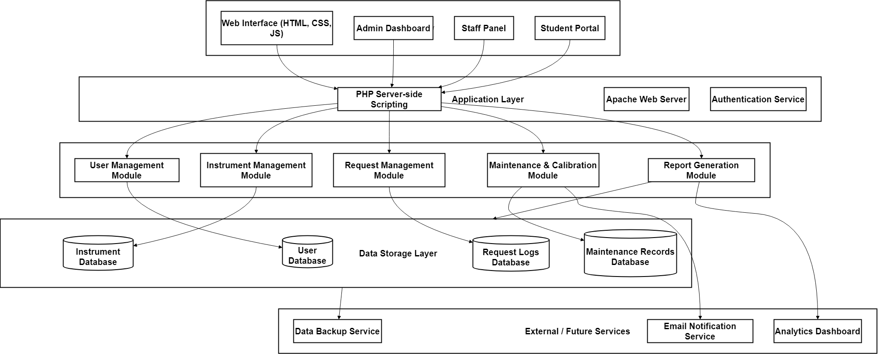
Figure 1.0 Architecture Diagram
This diagram shows the communication flow between the user interface, the web server, and the centralized database.This diagram shows the communication flow between the user interface, the web server, and the centralized database.

14. Conceptual Flow Diagram
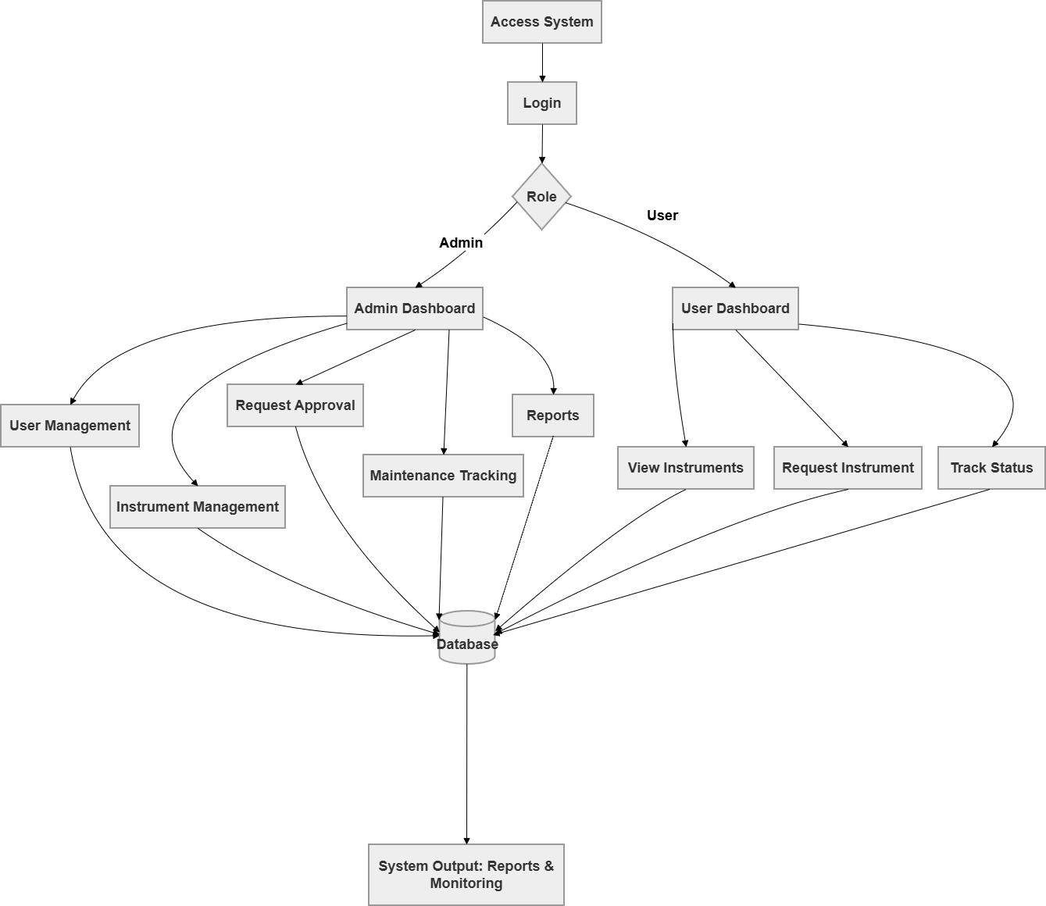
Figure 2.0 Conceptual Flow Diagram
This conceptual flow illustrates how users interact with the system, from logging in to managing instruments, processing requests, and generating reports. It also shows the flow of data between the client, server, and database.

15. Component Description
Frontend (User Interface)
- Built using HTML, CSS, and JavaScript for interactivity and responsiveness.
- Displays dynamic dashboards for each role (Admin and Users).
- Ensures intuitive navigation for tasks such as requesting, approving, or updating instrument details.
Backend (Server Logic)
- Implemented using PHP and hosted on Apache Server.
- Manages authentication, data validation, and system workflows.
- Handles CRUD operations and communication between the frontend and database.
Database (MySQL)
- Stores all system data including instrument records, users, maintenance schedules, and transaction logs.
- Utilizes relational tables with foreign keys to maintain data integrity.
- Provides data for reports and dashboards through queries.
APIs and Integrations (if applicable)
- May include future integration with calibration reminders or maintenance notifications through email or internal alerts.
- Provides extendable endpoints for connecting external modules or institutional systems.

16. Design Rationale
The design of the Inventory System for Medical Laboratory Instruments was guided by principles of simplicity, reliability, and maintainability.
- Three-Tier Architecture was selected to separate concerns and make the system easier to manage, allowing independent updates to the user interface, server logic, or database.
- PHP and MySQL were chosen for their proven compatibility, open-source availability, and ease of deployment on institutional networks.
- Modular Design ensures that each component—authentication, instrument tracking, maintenance, and reporting—functions independently yet cohesively.
- Security Considerations were implemented through user authentication and data validation to comply with the Data Privacy Act of 2012.
- Scalability was prioritized to accommodate more users and features, such as email notifications or cloud integration, in future system upgrades.
Overall, this architecture supports a user-centered, efficient, and reliable system that enhances laboratory instrument management and promotes operational efficiency.

17. Integration Objectives
The main goal of system integration is to ensure that all modules—User Management, Instrument Management, Request Management, Maintenance, and Reporting—operate cohesively as one reliable and synchronized system. Specifically, the integration aims to:
- Connect all user roles (Admin, Users (Students and Teachers) under one unified workflow.
- Ensure that every borrowing and returning transaction updates the database automatically.
- Maintain secure and accurate information flow across modules.
- Streamline the approval and monitoring process in real time.
The main goal of system integration is to ensure that all modules—User Management, Instrument Management, Request Management, Maintenance, and Reporting—operate cohesively as one reliable and synchronized system. Specifically, the integration aims to:
- Connect all user roles (Admin and Users)
- Ensure that every borrowing and returning transaction updates the database automatically.
- Maintain secure and accurate information flow across modules.
- Streamline the approval and monitoring process in real time.

18. Integration Approach
The system adopts a modular integration approach following the client-server model, where the frontend (user interface) communicates with the backend server using HTTP requests handled by PHP scripts. The backend processes these requests and interacts with the centralized MySQL database for storing, retrieving, and updating data. It also uses REST API to connect the mobile application and web-based admin panel, with data exchanged in JSON format.
The integration follows RESTful principles using standard HTTP methods:
- GET – Retrieve data from the database (e.g., viewing instruments or user accounts).
- POST – Add new records (e.g., adding an instrument or submitting a request).
- PUT – Update existing records (e.g., editing instrument details or request status).
- DELETE – Remove outdated or unnecessary data (e.g., deleting instrument entries).
This approach ensures efficient data handling, maintainability, and scalability of the system, while keeping integration logic simple and reliable.

19. Integration Architecture Diagram
The figure below illustrates how different components of the system interact with one another. Each user role (Admin and Users) accesses the system through the client interface. All interactions pass through the application layer, which handles system logic and communicates with the MySQL database for data processing.
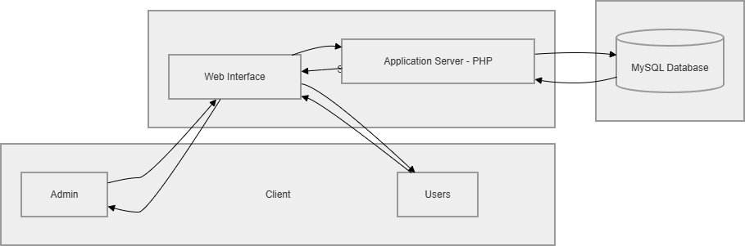
Figure 3.0 Integration Diagram

This architecture shows the system’s integrated structure and how data flows between layers through secure server-side processingThis architecture shows the system’s integrated structure and how data flows between layers through secure server-side processing.

20. Data Flow Diagrams (DFD)
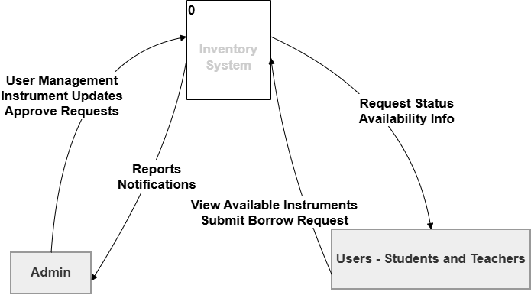
Figure 4.0 Context Diagram
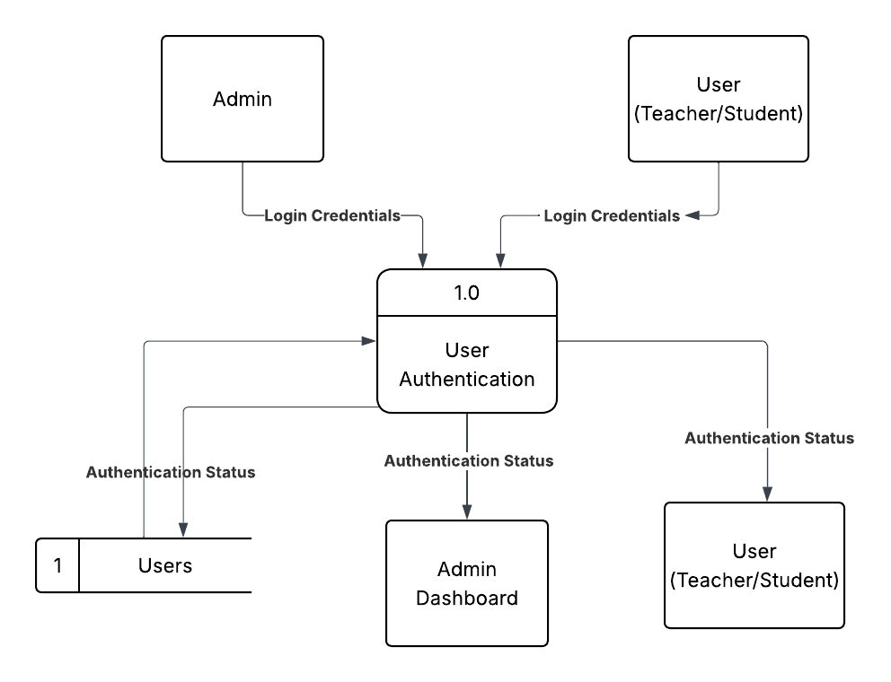
Figure 5.0 User Authentication
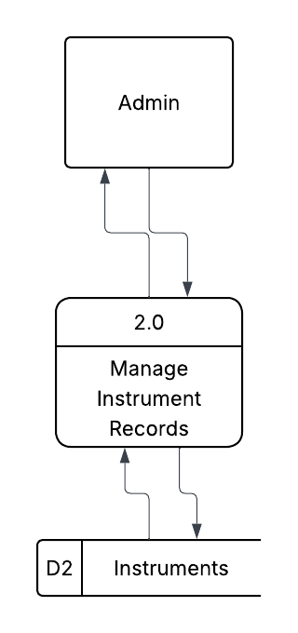
Figure 6.0 Management Instrument Record
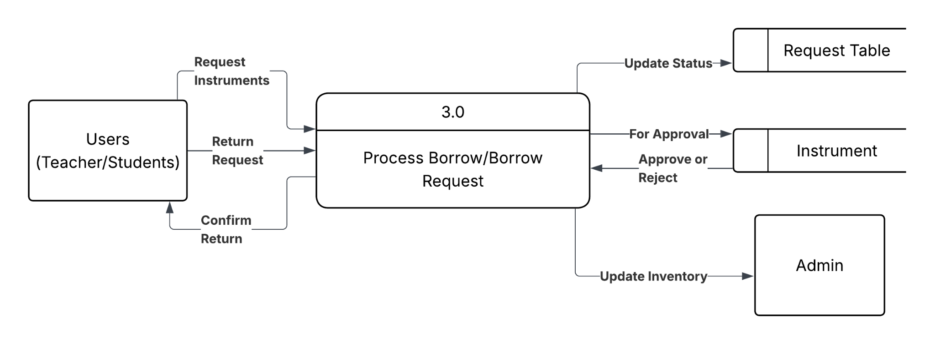
Figure 7.0 Process Borrow/Return Requests

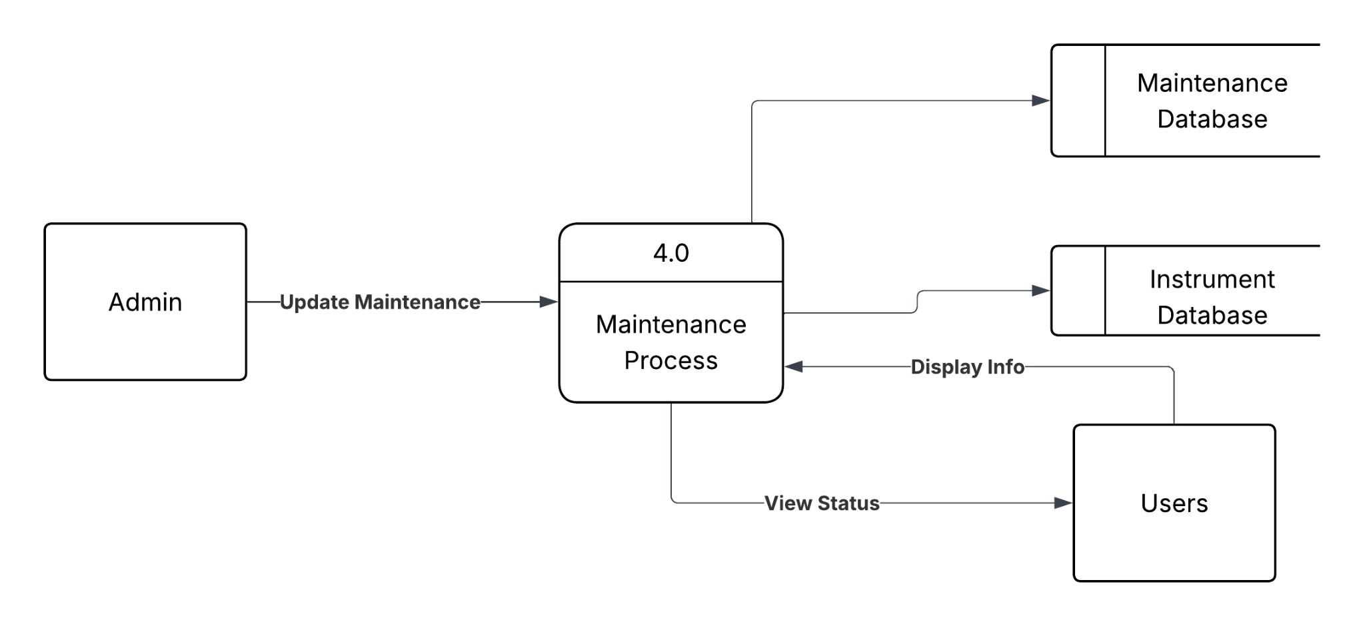

Figure 8.0 Track Instrument Status & Maintenance
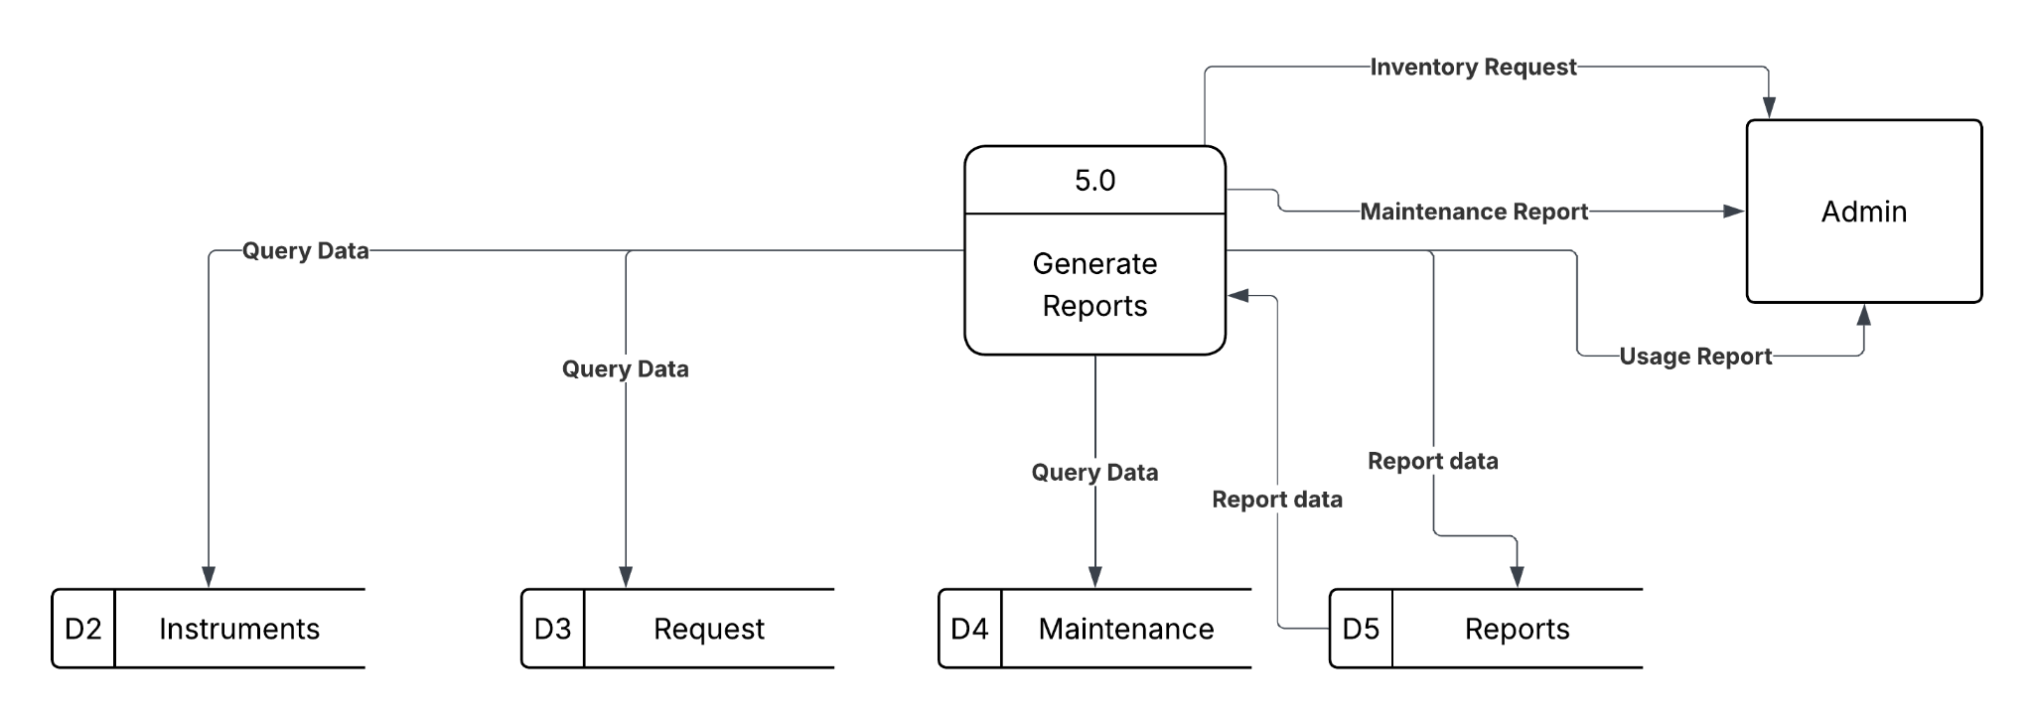
Figure 9.0 Generate Reports

21. Interface Specifications
The system uses form-based and RESTful interactions between the client and the server. Below is a sample of the API-like specifications used:

Endpoint | Description | Method | Request Parameters | Response
/login.php | Authenticates user credentials | POST | username, password | JSON: {status: success, role: admin}
/addInstrument.php | Adds new instrument record | POST | name, quantity, condition | JSON: {status: added}
updateInstrument.php | Updates existing instrument details | PUT | instrument_id, status | JSON: {status: updated}
/getInstrument.php | Retrieves instrument list | GET | none | JSON: {data: [...]}
/requestInstrument.php | Submits instrument borrow request | POST | student_id, instrument_id | JSON: {status: pending}
Table 1.0 Interface Specification
These endpoints ensure clear communication between the frontend interface and backend server during operations.

22. System Design and Implementation
22.1 Database Design

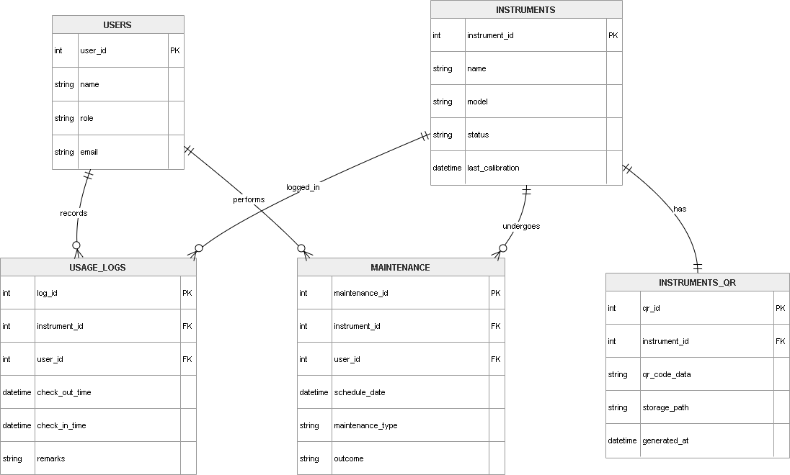
Figure 10.0 ER Diagram

This figure shows the core modules flow in our system.

The database follows a relational structure designed in MySQL.
Main Tables:
- Users - Stores login credentials and role identifiers.
- Instruments - Contains instrument names, quantities, and conditions.
- Requests - Logs borrowing and returning transactions.
- Maintenance – Tracks repair and calibration records.
- Reports – Summarizes system activity and generated logs
22.2 User Interface Design
The user interface was designed using HTML, CSS, and JavaScript to ensure simplicity and accessibility.
Each user role has a dedicated dashboard:
- Admin: Can manage all records, approve requests, and generate reports.
- Users (Students and Teachers): Can view available instruments, submit borrow requests, track request status, and monitor instrument availability.
The system includes a mobile application developed using Flutter, intended for students and teachers. The mobile application provides convenient access to system features through smartphones.
The key features of the mobile application include:
• QR Code Login – Users can log in by scanning their unique QR code.
• View Instruments – Users can check available laboratory instruments in real time.
• Submit Requests – Users can request to borrow instruments remotely.
• Track Requests – Users can monitor the status of their borrowing requests.
• QR Code Scanning – Instruments are scanned using QR codes for faster identification and transaction processing.
The mobile application enhances accessibility and allows users to interact with the system anytime and anywhere.
QR Code Integration
The system integrates QR code technology to streamline user authentication and instrument management. Each user is assigned a unique QR code for login, while each instrument is labeled with a QR code for easy identification.
This feature enables:
• Faster login without manual input
• Quick instrument identification
• Reduced human error
• Efficient tracking of borrowing and returning transactions
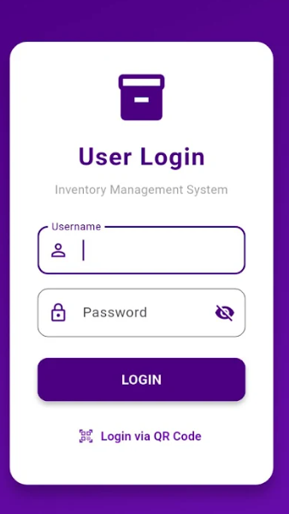
Figure 11.0 Login Page
This page allows authorized users such as Admin and Users (Students and Teachers) to securely access the system using their registered username and password or by scanning their unique QR code for fast and convenient sign-in.

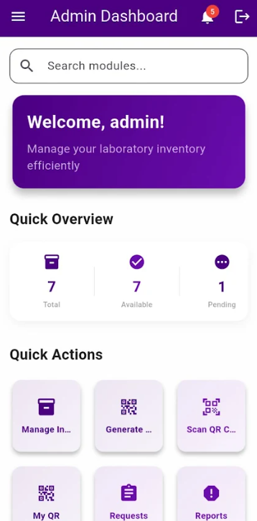
Figure 12.0 – Admin Dashboard

The Admin Dashboard provides a centralized overview and quick access to core modules. It surfaces notifications and system status to streamline navigation.

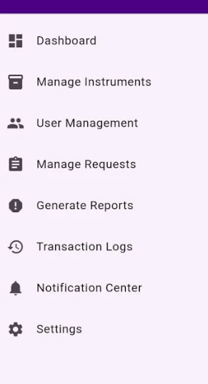
Figure 12.1 – Admin Panel: Modules

The Modules screen lists administrator-only features in a consistent navigation grid. It ensures fast discovery of tasks like user and inventory management.

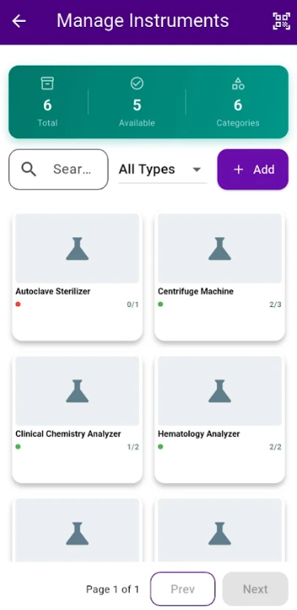
Figure 12.2 – Admin Panel: Manage Instruments

Manage Instruments allows creating, updating, and organizing equipment records. It maintains inventory accuracy across categories and locations.

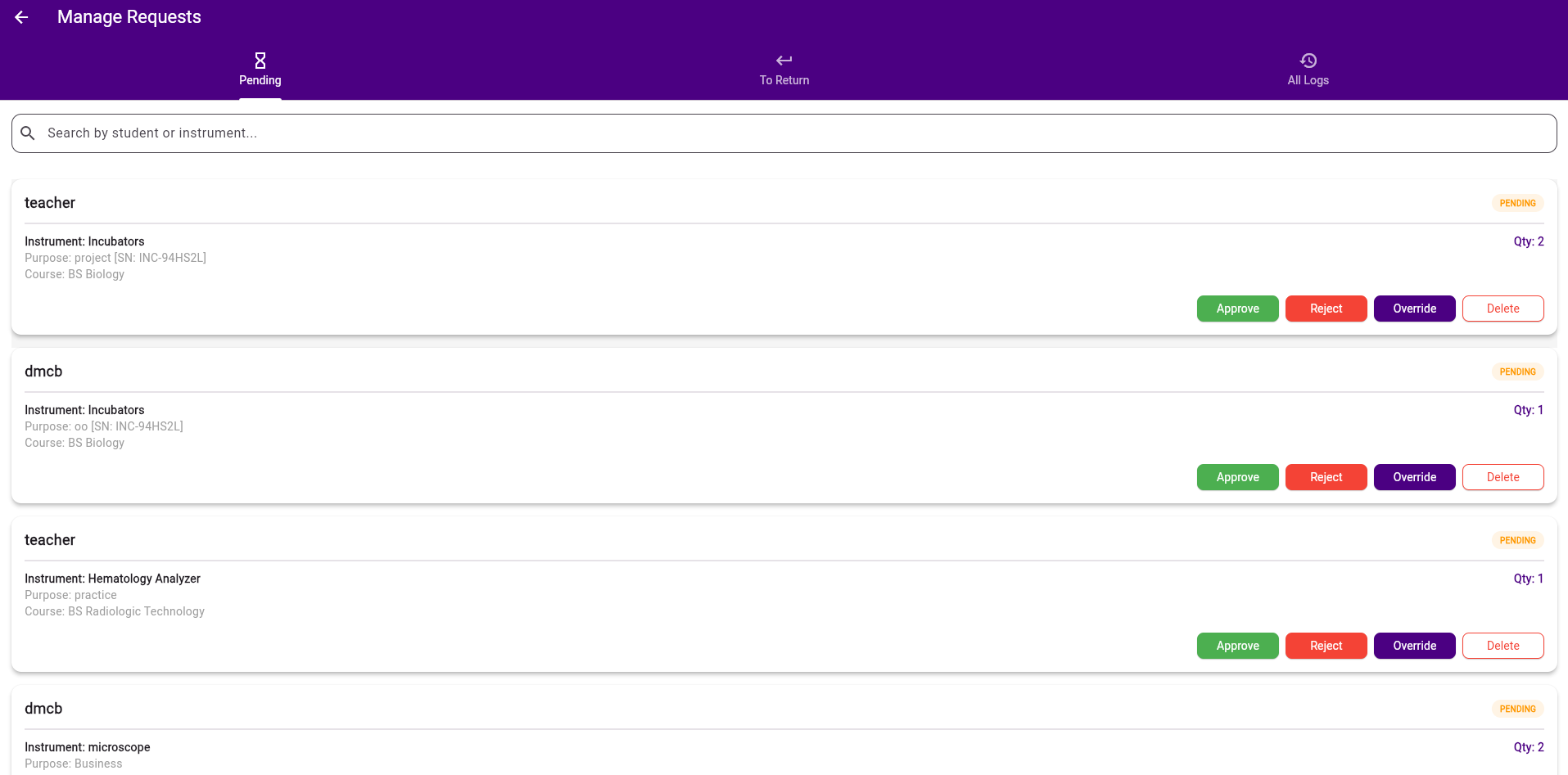
Figure 12.3 – Admin Panel: Manage Requests

Manage Requests enables review and approval/denial of borrowing requests. It helps balance availability with policy enforcement.

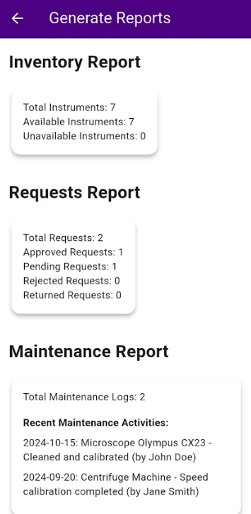
Figure 12.4 – Admin Panel:Generate Reports

Generate Reports provides summaries of utilization, trends, and activities. Exports and filters support periodic compliance and decision-making.

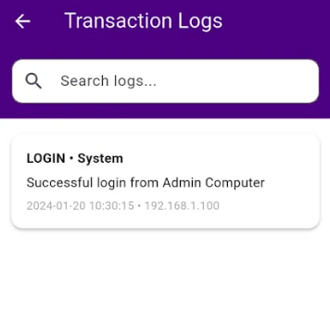

Figure 12.5 – Admin Panel: Transaction Logs

The Transactions Log records all borrow/return actions chronologically. Search and filtering support audits and traceability.

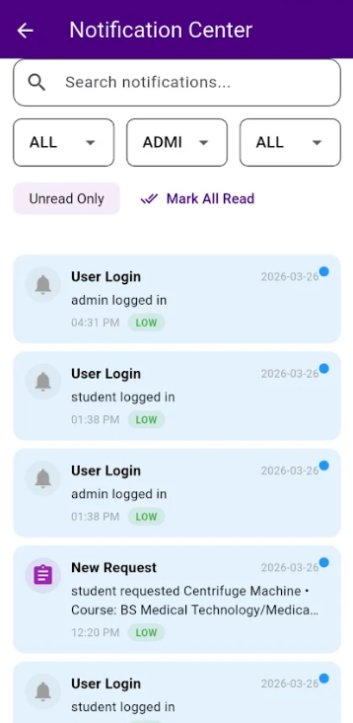
Figure 12.6 – Admin Panel:Notification Center

Notification Center aggregates system alerts and updates with read/unread states. It improves responsiveness through filtering and bulk actions.

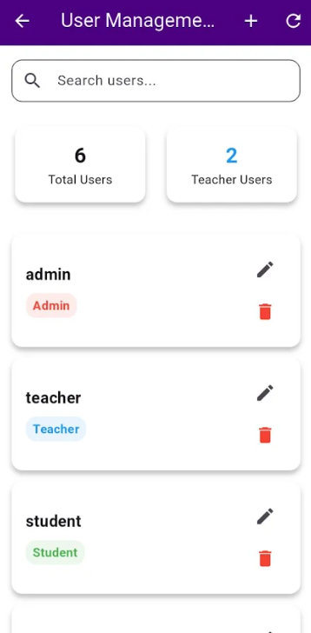
Figure 12.7 — Admin Panel: User Management
User Management handles accounts, roles, and access control. It enforces role-based permissions across the system.

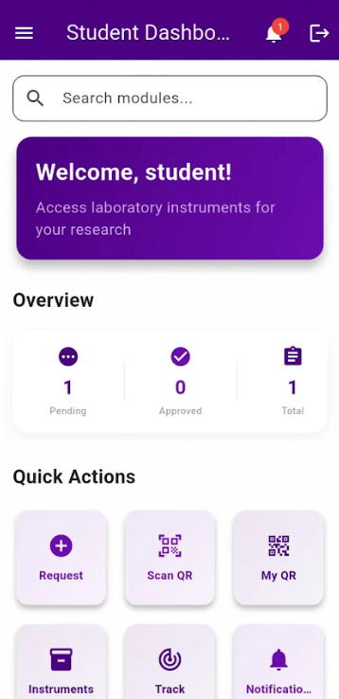Figure 13.0 – User Panel: Student Dashboard
Highlights key actions like requesting and tracking instruments. It simplifies access to frequently used features.
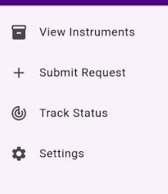
Figure 13.1 – User Panel:Modules

The design utilizes clear labels and standardized icons to ensure a consistent user experience. By organizing these core functions into a simplified vertical list, the interface minimizes the learning curve and allows students to navigate the system's capabilities efficiently.

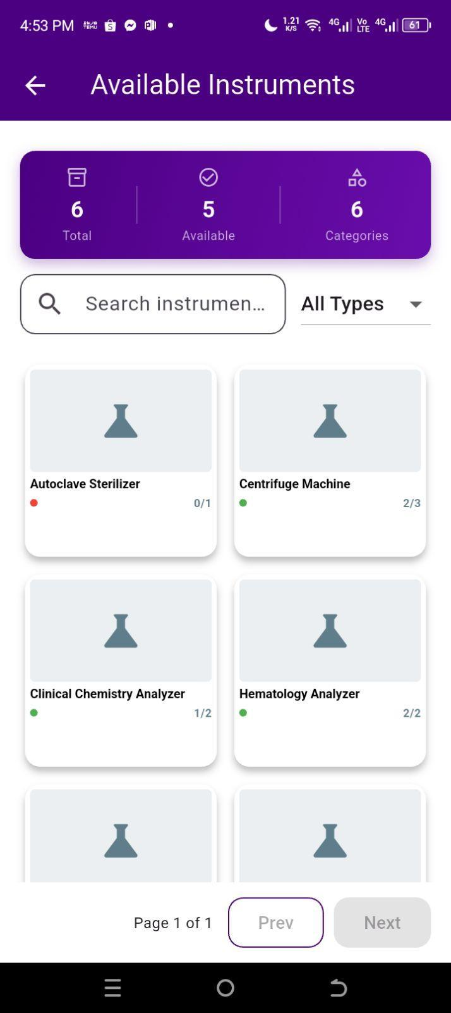
Figure 13.2 – User Panel: View Instruments
This displays the interface for browsing laboratory equipment. It features an inventory dashboard showing total counts, a search and filter bar for quick navigation, and item cards that list specific equipment and their availability. This module allows students to efficiently view and plan their requests based on real-time inventory data.

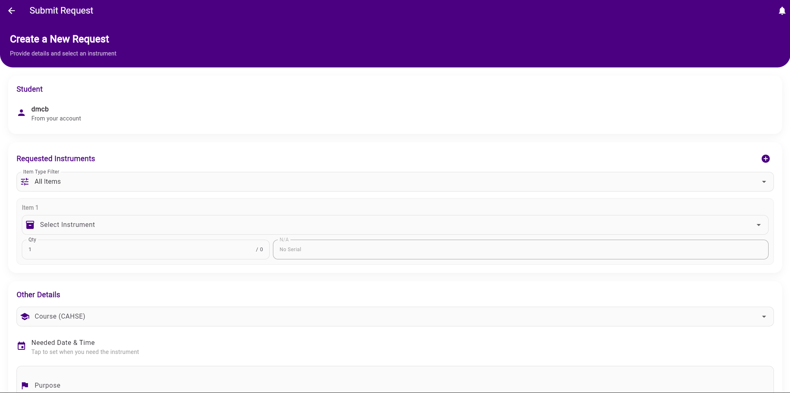
Figure 13.3 – User Panel: Submit Request

collects required information for borrowing. Validation ensures accurate, complete entries.

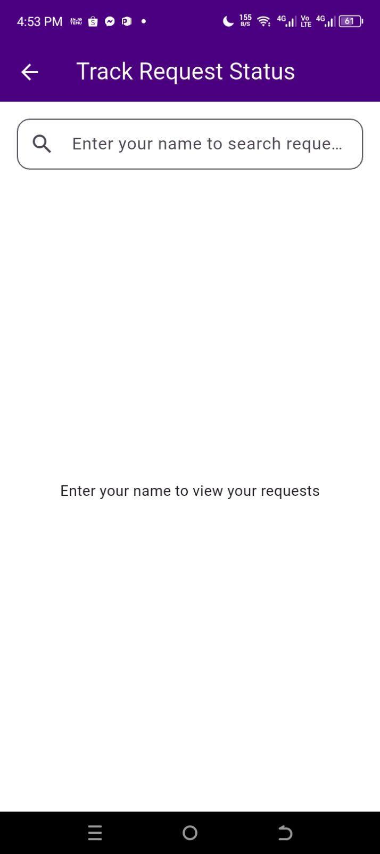
Figure 13.4 – User Panel: Track Status

Shows real-time request progress and outcomes. Transparency keeps students informed without staff intervention.

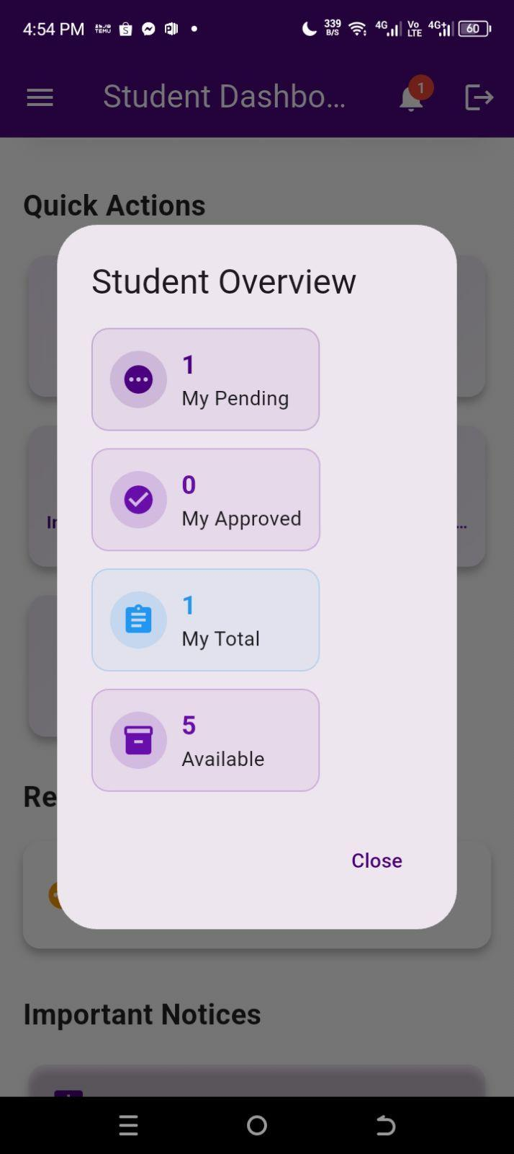
Figure 13.5 User Panel: Overview

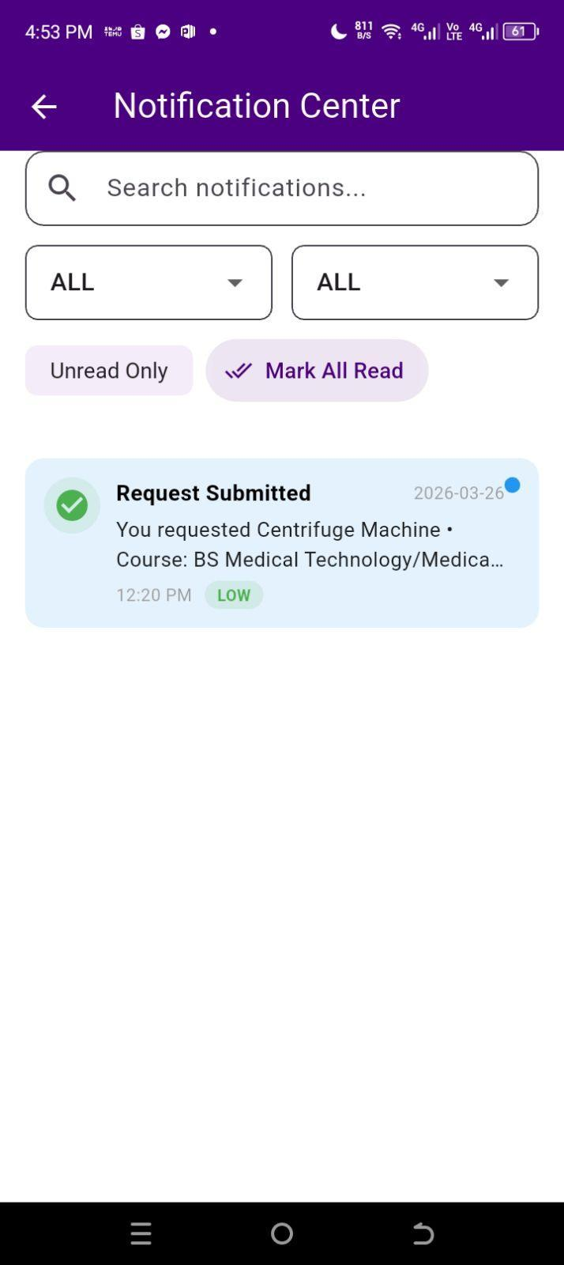
Figure 13.6 User Panel: Notification Center

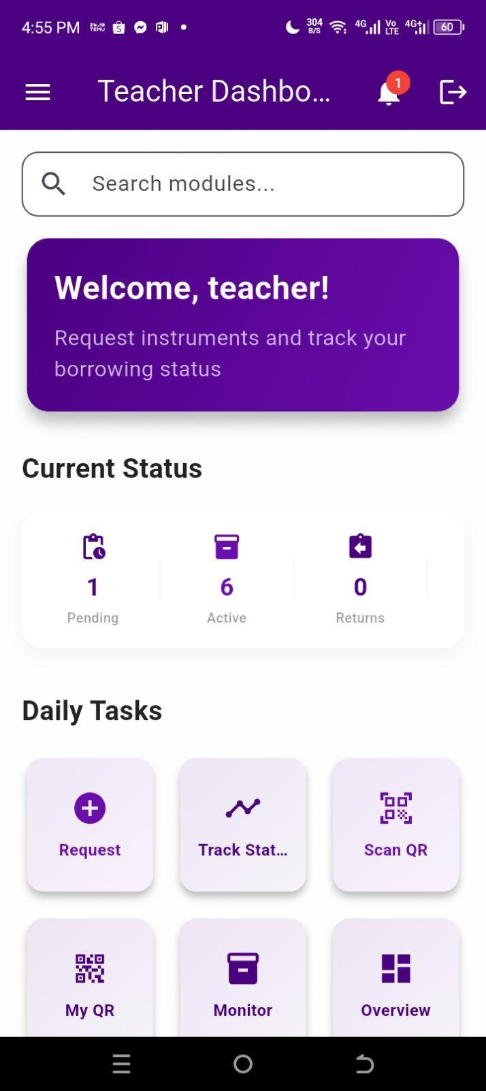

Figure 13.7 User Panel: Teacher Dashboard

23. Integration Implementation
All modules are connected through shared access to the central MySQL database.
When a user performs an action (e.g., adding, borrowing, or updating), the system updates the corresponding table automatically.
For future improvement, the system can integrate:
- Email Notification API for request approvals or due returns.
- Cloud Backup API for automated data backups.

24. Tools and Platforms

Category | Tool/Platform
IDE | Flutter
Version Control | GitHub
Hosting Platform | Web Server / Cloud Hosting
API Communication | REST API (PHP & JSON)
Design Tool | HTML CSS JS
Operating Environment | Web and Mobile (Online Access)
Table 2.0 Tools and Platforms

CHAPTER VII: SYSTEM TESTING AND VALIDATION
This chapter describes the rigorous testing processes performed on the system to validate its compliance with the functional and non-functional criteria set during the design process. Based on UTAUT theory, the researchers carried out tests to evaluate the system's performance, ease of use, reliability, and security. The findings shown in this chapter are based on actual experiences of system deployment and the usage experience of actual users after deployment.
The test phase is considered an important last step in the SDLC process. As explained by Pressman and Maxim (2023), current testing efforts verify whether the software complies with its specifications in light of the fast-paced nature of cloud computing. With respect to the Philippine setting, the significance of performing structured tests to assure that the system's quality is adequate and that it is fit for institutional use is highlighted by Estacio and Cabreros (2022).

26. Testing Strategy
The testing strategy used in this study follows a structured approach to ensure that the Inventory System for Medical Laboratory Instruments meets all required functionalities and performance standards. A testing strategy provides a framework that guides how testing activities are planned and executed to ensure system quality and reliability.
This study applied a multi-level testing approach, which includes unit testing, integration testing, system testing, and user acceptance testing (UAT). This approach allows the system to be evaluated from individual components up to the complete integrated system.
Using a layered testing strategy helps identify errors early, ensure proper interaction between modules, and verify that the system is ready for actual use (GeeksforGeeks, 2025).
27. Unit Testing
Individual unit testing was carried out on each and every individual module and/or component of the program to ensure their proper functioning in isolation. Both black-box testing and white-box testing methods were used for testing each module.
These were some of the modules which underwent individual unit testing:
- Module for User Authentication (Login, Registration, Password Reset) Module for Instrument Management
- Module for Request Processing
- Module for Data Entry & Form Validation
- Module for Database Operations (CRUD)
- Report Generation Module
Each module was individually tested by feeding it a set number of test cases consisting of valid inputs, invalid inputs, and even edge case inputs. Any detected defect during the test was fixed and then re-tested until all test cases were successfully completed.(GeeksforGeeks, 2025)

28. Integration Testing
The purpose of performing integration testing was to ensure that individual tests carried out on the modules within the Inventory System for Medical Laboratory Instruments function well when integrated into the entire system. The process was concentrated on checking whether there is good communication between system components.

This includes data exchange between the interfaces listed below:

- Interface between frontend and backend using PHP requests/responses
- Data exchange with the database using MySQL
- Exchange and synchronization between web and mobile applications using REST API
- Sessions and users authentication management among others

The incremental integration technique was employed whereby core components like authentication and database interactions were integrated first followed by their dependent components such as request processing and reporting.

Problems with regard to data synchronization, response, and communication have been detected and corrected. This has helped to validate whether the integrated modules work as a whole system ( IBM, 2023).

29. System Testing (End-to-End)

System testing was performed to ensure that the entire and fully integrated Inventory System for Medical Laboratory Instruments met all its requirements.

Test cases were designed for end-to-end (E2E) testing, which simulates user processes from start to finish. E2E test cases were developed considering how the software will be used in practice, and all processes will function together properly.

The scenarios that were tested included:

- Login and user authentication procedure
- Management of instruments' records
- Creation and approval of borrowing requests
- Reporting of recorded data
- Multi-user access system performance
In addition, the performance of the system was also checked during the test, including such parameters as response time and data accuracy.
It turned out that the system operates flawlessly and all components cooperate with each other successfully. That means that all requirements have been met (Powell & Smalley, 2025).
30. Test Cases and Results
This section presents the test cases designed to validate system functionality, along with the expected and actual results obtained during testing. The test cases were categorized by module and testing level. A total of forty-eight (48) test cases were executed across all modules.
Table 3.0 Summary of Test Cases – Unit Testing Results
TC no. | Module / Feature | Test Description | Expected Result | Actual Result | Status
TC01 | User Authentication | Valid username & password login | Successful login, redirect to dashboard | Login successful, dashboard loaded | Passed
TC02 | User Authentication | Invalid password attempt | Error message displayed | Error displayed: 'Invalid credentials' | Passed
TC03 | User Authentication | Blank username field on login | Validation error shown | Validation warning triggered | Passed
TC04 | Registration Module | New user registration with valid data | Account created, confirmation email sent | Account created; email sent | Passed
TC05 | Registration Module | Duplicate email registration | Error: email already exists | Duplicate error displayed | Passed
TC06 | Form Validation | Required field left blank on submission | Error prompt on blank fields | All blank fields flagged | Passed
TC07 | Form Validation | Special characters in text input | Input sanitized or rejected | Input sanitized correctly | Passed
TC08 | Database – Create | Add new record to database | Record saved, success message shown | Record saved successfully | Passed
TC09 | Database – Read | Retrieve record by ID | Correct record displayed | Record displayed correctly | Passed
TC10 | Database – Update | Modify existing record | Updated record reflected in DB | Record updated correctly | Passed
TC11 | Database – Delete | Delete a record from database | Record removed, confirmation shown | Record removed, confirmation shown | Passed
TC12 | Report Generation | Generate system report | Report rendered and viewable within the module | Report displayed correctly in-module | Passed
TC13 | Notifications | Trigger system notification | Notification appears on user account within 60 seconds | Notification received on account dashboard | Passed
Legend: TC = Test Case | All test cases above were retested after defect correction. Final Status reflects post-correction results.
Table 3.1 Summary of Integration Testing Results
TC No. | Interface / Integration Point | Test Scenario | Expected Result | Actual Result | Status
IT-01 | Frontend-Backend API | POST request to create record | 200 OK + record ID returned | 200 OK, record ID returned | Passed
IT-02 | Frontend-Backend API | GET request for all records | 200 OK + JSON data array | JSON array returned correctly | Passed
IT-03 | Backend-Database | Multi-table JOIN query | Correct combined data returned | Correct data returned | Passed
IT-04 | In-App Notification System | Trigger notification on new entry | Notification delivered to user account | Notification appeared in dashboard in 5s | Passed
IT-05 | Session & Token | JWT token validation on protected route | Valid token grants access | Access granted correctly | Passed
IT-06 | Cross-Module Data Flow | Form submission DB → Dashboard update | Dashboard reflects new entry | Dashboard updated in <2s | Passed

31. Web Integration Testing
Web integration testing focused on verifying the system's ability to communicate reliably across web-based interfaces and external services. This is especially critical for systems that rely on RESTful APIs, cloud-hosted databases, and third-party integrations. The researchers adopted the testing criteria outlined by Sommerville (2016) and adapted them to the web application architecture used in the system.

30.1 API Response Verification
All API endpoints were tested for correctness of HTTP status codes, response payload structure, data type accuracy, and response time. Table 7.3 presents the API endpoint testing results.

Table 4.0 API Endpoint Testing Results
Endpoint | Method | Description | Expected Status | Actual Status | Avg. Response Time | Result
/api/auth/login | POST | Authenticate user | 200 OK | 200 OK | 142 ms | Passed
/api/users | GET | Fetch all users | 200 OK | 200 OK | 98 ms | Passed
/api/users/{id} | GET | Fetch user by ID | 200 OK | 200 OK | 85 ms | Passed
/api/records | POST | Create new record | 201 Created | 201 Created | 187 ms | Passed
/api/records/{id} | PUT | Update record | 200 OK | 200 OK | 195 ms | Passed
/api/records/{id} | DELETE | Delete record | 204 No Content | 204 No Content | 110 ms | Passed
/api/reports/view | POST | Preview report | 200 OK | 200 OK | 1.2 s | Passed
/api/notify | POST | Send notification | 202 Accepted | 202 Accepted | 233 ms | Passed

30. Cross-Origin Request Testing (CORS)
The CORS test ensured that the application appropriately restricts or allows access based on the origin of the requests to avoid any other websites exploiting the API of the back-end application. This was accomplished through the verification of authorized origins to confirm the success of requests that were permitted while ensuring that unauthorized ones were not allowed access. Moreover, the preflight request tests were done to verify the correctness of the security headers sent back by the server during OPTIONS requests.

31. Security Testing
Security testing was carried out to ascertain whether the Inventory System for Medical Laboratory Instruments will be able to protect any data stored in the system and prevent any form of access by an unregistered person. Security testing concentrated on ensuring whether the system had appropriate means of protecting system data and preventing unauthorized access by conducting tests on system authentication and access control. This was achieved by trying to log into the system using invalid usernames and passwords. This test was carried out to make sure the system responds with an appropriate message when an attempt is made to log into the system using an invalid account. Role-based access control testing was also done to see whether any unauthorized person gains access to administrative features within the system.

32. Authentication and Authorization Testing
The system’s security levels were authenticated to guarantee that only legitimate users can access particular information and functionalities.

The authentication tests involved:
- Credential Validation: The test evaluated whether the system uses valid or invalid credentials during the sign-in process.
- Role-Based Access Control (RBAC): It confirmed whether ordinary users cannot access administrative functions, like creating accounts and changing settings across the whole system.
- Session Management: It checked whether the system manages user sessions effectively by terminating them after inactivity.
- Password Policy Implementation: It confirmed whether the system enforces security practices, like concealing passwords and displaying error messages when attempts fail.

33. Data Synchronization Testing
The data synchronization test ensured that the information is synchronized at all times within all modules. It was found out that any changes done to the laboratory record or maintenance status would be automatically updated on the database, dashboard, and report. In addition, the software guarantees data integrity even in case of simultaneous access by several users.
34. Input Validation Testing

The test for input validation was performed to make sure that the system sanitizes all inputs from the web form and avoids any malicious activity on it. The developers made sure that the inputs could not be submitted in other forms, thus ensuring protection from XSS and SQL injection. The test also included checking whether the system would enforce all restrictions regarding the character limits and required fields. All the inputs that did not meet the criteria were filtered by the system.

35. Vulnerability Assessment
A vulnerability assessment was conducted using industry-standard tools. The system was scanned for known vulnerabilities in its dependencies, server configuration, and exposed endpoints.

Table 5.0 Security Testing Results Summary
Security Test Area | Test Performed | Threat Level | Finding | Status / Remediation
Authentication | Brute force login simulation (100 attempts) | High | Account lockout triggered after 5 attempts | Passed – Lockout enforced
Authentication | Session token expiry validation | Medium | Session expired after 30-min inactivity | Passed – Session management OK
Authorization | Unauthorized access to admin routes | High | Access denied; 403 Forbidden returned | Passed – RBAC enforced
Input Validation | SQL injection via login form | Critical | Input sanitized; injection attempts blocked | Passed – Parameterized queries used
Input Validation | XSS via comment/text fields | High | Script tags stripped or escaped | Passed – Output encoding applied
Data Encryption | HTTPS/TLS verification | High | TLS 1.2+ enforced; HTTP redirected to HTTPS | Passed – SSL certificate valid
Dependency Scan | Outdated library vulnerability check | Medium | 2 outdated packages were identified | Resolved – Packages updated to latest
CORS Policy | Cross-origin request from unauthorized domain | Medium | Request blocked; CORS error returned | Passed – Origin whitelist enforced

29. Error Handling and Troubleshooting
Error handling and troubleshooting features were included to ensure that the system runs smoothly and gives feedback whenever there are problems. The system has been tested for several types of errors like invalid passwords, missing fields in forms, and erroneous inputs. Whenever an error happens, the system provides feedback to the user on how he/she can fix the issue. Validation features have also been incorporated to guarantee that all required fields are filled out correctly before sending them to the database. For problems caused by system errors, like disconnection from the Internet, the administrator is able to solve the problem after conducting tests and verification on the system/database.

Table 6.0 Common Errors and Resolutions Encountered
No. | Error / Issue | Error Code | Root Cause | Phase Found
1 | Login failure with correct credentials | HTTP 401 | JWT secret key mismatch between environments | Integration
2 | Database connection timeout | DB Error 1040 | Max connections exceeded during load test | System
3 | File upload fails for files >5MB | HTTP 413 | Server's default payload limit not configured | UAT
4 | Report PDF renders blank pages | N/A | Async rendering not awaited; data fetched too late | System
5 | CORS error on production API calls | HTTP 403 | Production domain not added to CORS whitelist | Integration
6 | Dashboard charts not updating in real-time | N/A | WebSocket connection dropping after 60s | UAT
7 | Form submitting duplicate records | N/A | Double-click on submit button triggered twice | UAT
8 | Search returning incorrect results | N/A | Case-sensitive query mismatch in SQL | System

33. UTAUT Framework and User Acceptance Evaluation
For the analysis of the user acceptance of the medical laboratory inventory management system, the Unified Theory of Acceptance and Use of Technology (UTAUT) approach was adopted. This theory takes into account four essential factors: Performance Expectancy, Effort Expectancy, Social Influence, and Facilitating Conditions. The assessment process comprised collection of opinions and attitudes of end users about their intention to use the system

33. UTAUT Constructs
Table 7.0 UTAUT Constructs and Definitions

No. | Construct | Definition | Measurement Focus
1 | Performance Expectancy (PE) | The degree to which the user believes that using the system will help them achieve gains in job performance. | Usefulness, efficiency, productivity improvement
2 | Effort Expectancy (EE) | The degree of ease associated with the use of the system. | Ease of use, learnability, clarity of interface
3 | Social Influence (SI) | The degree to which the user perceives that important others believe they should use the system. | Peer influence, supervisory support, social norms
4 | Facilitating Conditions (FC) | The degree to which the user believes that an organizational and technical infrastructure exists to support the use of the system. | Technical support, resource availability, compatibility
5 | Behavioral Intention (BI) | The extent to which users intend to use the system in the future. | Willingness to recommend, continued use intention

33. Respondent Profile
The UAT involved fifty (100) respondents who were actual users of the deployed system. The respondents included students, faculty members, and administrative staff who regularly interact with the system in their respective roles

Table 8.0 Profile of UAT Respondents
Category | Group | Male | Female | Total
User Role | Students (End User)
User Role | Teacher (End User)
User Role | System Administrators
Age Group | 18–25 years old
Age Group | 26–35 years old
Tech Proficiency | Beginner
Tech Proficiency | Intermediate
Tech Proficiency | Advanced

33. UTAUT Survey Questionnaire
USER ACCEPTANCE TESTING (UAT) SURVEY
Based on the Unified Theory of Acceptance and Use of Technology (UTAUT)
—--------------------------------------------------------------------------------------------------------------------------------------------------------
INSTRUCTIONS: Please rate each statement based on your experience with the system. Use the scale:
5 – Strongly Agree (SA)
4 – Agree (A)
3 – Neutral (N)
2 – Disagree (D)
1 – Strongly Disagree (SD)
—--------------------------------------------------------------------------------------------------------------------------------------------------------
PART I. RESPONDENT INFORMATION
Name (optional): | Date:
Role/Position (Student, Teacher, Admin): | Department/Section:
Age: ________ Gender: ☐ Male ☐ Female | Tech Proficiency: ☐ Begginer ☐ Intermediate ☐ Advanced
PART II. PERFORMANCE EXPECTANCY (PE)
The system helps me accomplish my tasks more effectively.
No. | Statement / Question | 5  SA | 4  A | 3  N | 2  D | 1  SD
1 | I find the system useful in managing laboratory inventory.
2 | Using the system enables me to accomplish tasks more quickly.
3 | The system increases my productivity in tracking instruments.
4 | The system improves the accuracy of my record-keeping.
5 | Using the system enhances my overall effectiveness at work.
PART III. EFFORT EXPECTANCY (EE)
The system is easy to use and learn.
No. | Statement / Question | 5  SA | 4  A | 3  N | 2  D | 1  SD
1 | Learning to operate the system is easy for me.
2 | I find it easy to get the system to do what I want it to do.
3 | My interaction with the system is clear and understandable.
4 | I find the system flexible to interact with.
5 | It is easy for me to become skillful at using the system.
PART IV. SOCIAL INFLUENCE (SI)
People around me support my use of the system.
No. | Statement / Question | 5  SA | 4  A | 3  N | 2  D | 1  SD
1 | People who are important to me think that I should use the system.
2 | People who influence my behavior think that I should use it.
3 | The management has been helpful in the use of the system.
4 | In general, the organization has supported the use of the system.
5 | My colleagues believe that the system is beneficial for the lab.
PART V. FACILITATING CONDITIONS (FC)
Resources and support are available to help me use the system.
No. | Statement / Question | 5  SA | 4  A | 3  N | 2  D | 1  SD
1 | I have the resources necessary to use the system.
2 | I have the knowledge necessary to use the system.
3 | The system is compatible with other systems I use
4 | A specific person or group is available for assistance.
5 | I can easily access the system using the available hardware.
PART VI. BEHAVIORAL INTENTION (BI)
I intend to continue using the system in the future.
No. | Statement / Question | 5  SA | 4  A | 3  N | 2  D | 1  SD
1 | I intend to use the system in the next few months.
2 | I predict I would use the system on a regular basis.
3 | I plan to use the system to improve my work performance.
4 | I would recommend the system to my co-workers.
5 | I am willing to continue using the system in the future.
PART VII. Open-Ended Questions
Please provide your honest comments and suggestions to help improve the system.
- What feature of the system do you find most useful? Why?
____________________________________________________________________________________________________________________________________________________________________
- What difficulties or challenges did you encounter while using the system?
____________________________________________________________________________________________________________________________________________________________________
- What improvements or additional features would you suggest for the system?
____________________________________________________________________________________________________________________________________________________________________
- How has the system affected your workflow or daily tasks?
____________________________________________________________________________________________________________________________________________________________________
- Any other comments, suggestions, or feedback?
____________________________________________________________________________________________________________________________________________________________________

33. Data Analysis and Interpretation
The data collected from the UTAUT survey were analyzed using descriptive statistics, specifically weighted mean and standard deviation, and interpreted using a five-point Likert scale. This analysis transforms raw testing data into actionable insights to determine the system's readiness and ensures the platform meets its functional and user-centric objectives. The scale interpretation follows the rating scale guidelines commonly used in Philippine capstone and thesis studies (Xue et al., 2024) ) as shown in the table below:
Table 9.0 Likert Scale Interpretation Legend
Scale | Numerical Value | Weighted Mean Range | Descriptive Interpretation
Strongly Agree | 5
Agree | 4
Neutral | 3
Disagree | 2
Strongly Disagree | 1

33. Performance Expectancy Results
Table 7.9 presents the weighted mean scores for the Performance Expectancy (PE) construct. A high PE score indicates that users perceive the system as a valuable tool that enhances their work performance.
Table 10.0 Performance Expectancy – Descriptive Statistics (n = 50)
Item | Statement | Weighted Mean | Interpretation
PE1
PE2
PE2
PE4
PE5
Overall Weighted Mean:

33. Consolidated UTAUT Results
Table 7.9 presents the weighted mean scores for the Performance Expectancy (PE) construct. A high PE score indicates that users perceive the system as a valuable tool that enhances their work performance.
Table 11.0 Performance Expectancy – Descriptive Statistics (n = 50)
No. | UTAUT Construct | Weighted Mean | Descriptive Rating
1 | Performance Expectancy (PE)
2 | Effort Expectancy (EE)
3 | Social Influence (SI)
4 | Facilitating Conditions (FC)
5 | Behavioral Intention (BI)
Overall Weighted Mean:

33. Consolidated UTAUT Results
(After gathering Data)
Table 11.0 Performance Expectancy – Descriptive Statistics (n = 50)
UTAUT Construct | Pearson's r | p-value | Significance | Decision
Performance Expectancy (PE)
Effort Expectancy (EE)
Social Influence (SI)
Facilitating Conditions (FC)
Behavioral Intention (BI)

CHAPTER VIII: SYSTEM DEPLOYMENT AND MAINTENANCE

34. Deployment Environment

The Inventory System for Medical Laboratory Instruments is deployed within a cross-platform environment, integrating web-based administration with mobile accessibility. The system is hosted on a centralized server to facilitate real-time data synchronization and ensure high availability for authorized stakeholders.
The infrastructure is categorized into three primary layers:

Server-Side Infrastructure:

The server-side infrastructure is responsible for processing requests, managing system logic, and storing data. It includes:
- Web Server (Apache) – Responsible for managing HTTP requests and serving the application’s web-based assets.
- Backend Logic (PHP) – Executes server-side processing, business logic, and API management.
- Database Management System (MySQL)– Serves as the relational data store for instrument records, user credentials, and transaction logs.

Client-Side Environment
The client-side environment allows users to interact with the system through different platforms:
- Web Interface-Accessible via modern standards-compliant browsers (e.g., Google Chrome, Microsoft Edge).
- Mobile Application- A cross-platform application developed using the Flutter framework, optimized for Android devices to provide remote inventory tracking.

Network Requirements
A stable internet connection is requisite to maintain persistent communication between the client applications and the RESTful API, ensuring data integrity across all platforms.
Overall, this deployment environment ensures that administrators, students, and teachers can access the system anytime and anywhere. It supports the system’s objective of improving accessibility, efficiency, and real-time monitoring of laboratory instruments.
35. Deployment Steps
The deployment process followed a structured lifecycle to ensure a seamless transition from development to production with minimal operational downtime.
- System Preparation: Finalization of source code followed by rigorous validation and unit testing.
- Environment Configuration: Provisioning of the Apache web server and configuration of the PHP runtime and MySQL environment.
- Database Migration: Implementation of the relational schema (including users, instruments, requests, and maintenance tables) and population of initial baseline data.
- Application Deployment: Uploading of core system files to the production server and configuration of environmental variables, including API endpoints and secure database credentials.
- Integration and Interoperability: Establishing secure communication between the web and mobile layers using a RESTful API architecture and JSON data exchange.
- Production Testing: Conducted end-to-end testing in the live environment, encompassing CRUD operations, authentication flows, and real-time synchronization.
- User Training and Orientation: Facilitating knowledge transfer sessions for laboratory personnel to ensure proficiency in system workflows.
- Production Launch (Go-Live): Formal decommissioning of the manual logbook system in favor of the automated digital inventory platform.

36. Version Control and CI/CD Practices
To ensure system scalability and maintainability, the development lifecycle utilized modern DevOps principles:
- Version Control: GitHub served as the centralized repository, enabling granular change tracking, collaborative development, and version reversion capabilities.
- Continuous Integration (CI): Iterative code updates were subjected to verification prior to merging, ensuring that new features maintained compatibility with existing core functionalities.
- Continuous Deployment (CD): Validated updates were systematically deployed to the production server, allowing for non-disruptive bug fixes and UI enhancements.

37. Maintenance and Monitoring
Post-deployment, the system is governed by a continuous maintenance and monitoring framework to ensure optimal performance, security, and reliability.

37.1 System Maintenance
System maintenance involves regular updates and improvements to ensure that the system remains functional and efficient over time. The following maintenance activities are performed:
Corrective Maintenance
This involves identifying and fixing bugs or errors encountered after deployment to maintain system stability.
Adaptive Maintenance
Updates are applied to ensure compatibility with new devices, operating systems, or web browsers as technology evolves.

Perfective Maintenance
Enhancements and improvements are implemented based on user feedback to improve system usability and performance.
Preventive Maintenance
Routine activities are conducted to avoid potential issues, including:
- Regular database backups
- System performance checks
- Updating system components when necessary

37.2 System Monitoring
System monitoring is essential to ensure continuous operation, detect issues early, and maintain overall system security. The following monitoring activities are implemented:
- Performance Monitoring
The system’s response time and loading speed are regularly evaluated to ensure smooth user experience.
- Database Monitoring
Data accuracy and integrity are maintained by monitoring database transactions and storage usage.
- Security Monitoring
The system tracks login attempts and detects unauthorized access to maintain secure authentication and access control.
- Error Logging
System errors are recorded and analyzed to support troubleshooting and continuous system improvement.

CHAPTER IX: SECURITY AND PERFORMANCE CONSIDERATION
This chapter discusses the security precautions and performance enhancement techniques employed to guarantee the effectiveness, data accuracy, and speed of the Inventory System for Medical Laboratory Instruments.

38. Security Measures
The system uses a number of security levels to safeguard the sensitive data stored within the laboratory as well as ensure that there is proper access control to only the right individuals.
Authentications and Authorizations:
- Secure Sign In: The system has a secure sign-in process to guarantee that only authorized personnel have access
- QR Code Authentications:For improved security and efficiency, this system is capable of scanning QR codes for more efficient logins.
- Role Based Access Control (RBAC): The system manages user roles from a central point, taking into consideration the difference between administrator, student, and teacher roles.
Data Protection and Privacy:
- Compliance with Data Privacy Act: The system is built to be compliant with the Data Privacy Act of 2012 (Republic Act No. 10173). This ensures that all user and instrument data are stored and processed in a secure manner.
- Minimal Data Collection: In order to uphold high ethical standards, no information other than that which is absolutely necessary for the functioning of the computer systems will be collected from any individual.
- Traceability and Accountability: Every activity like borrowing and returning of instruments is documented in order to make sure that everything done is accounted for and people become responsible.

Technical Security Controls:
- Cross-Origin Request Testing (CORS): The application uses CORS policy to either allow or deny access depending on the origin of the request. This ensures that the backend API is not exploited by any other website outside the application.
- Security Header Verification: Preflight request tests are done to ensure that security headers sent from the server are correct.

39. Performance Optimization
In order to satisfy the requirements of a medical laboratory, certain techniques were used to enhance the speed, availability, and responsiveness of the system.

Architectural Efficiency:
- Three-Tier Model: With the use of Presentation Layer, Application Layer, and Data Layer, the system becomes more modular, enabling changes in one layer without impacting the efficiency of other layers.

- RESTful API Integration: RESTful API is used for continuous and light interaction between the platforms on the client side (web and mobile) and the server to provide rapid transmission of data.

Database and Backend Tuning:
- Synergistic Processing: MySQL for storing relational data and PHP for the server-side programming makes the process of managing the CRUD activities and report generation fast.
- Real-Time Synchronization: Hosting through the central server helps to keep all information updated at once in the dashboard to all stakeholders who are authorized.

Continuous Improvement:
- CI/CD Practices: This methodology makes it possible to carry out deployments of bug fixes and UI improvements with no disruptions in service delivery.

40. Risk Management
The aim of risk management is to identify possible problems that may arise due to technical or operational issues and develop strategies to minimize or prevent them to ensure smooth running of the lab.
System Failure Mitigation:
- Error Handling: There is a mechanism for validation in the system, which would ensure that the erroneous data cannot be entered in the system. This is a major threat faced by the manual system.
- Data Loss Prevention: The maintenance strategy entails frequent backup activities and constant updates to avoid any loss of data or replication of records.

Operational Continuity:
- Transition Management: In order to avoid system failure or rejection at the time of launch, the “Go-Live” approach was adopted wherein the manual logbook system would be phased out only when the digital system was certified.
- Internet Dependency: The system’s need for a constant internet connection can be controlled through proper design to allow quick information transfer in the network infrastructure.

Security Risk Control:
- Unauthorized Access: The processes of authentication and security testing focus on preventing unauthorized individuals from accessing the system or the data within it.

30. REFERENCES

Pirta, R., & Grabis, J. (2015). Integrated Methodology for information system change control based on enterprise architecture models. Information Technology and Management Science, 18(1). https://doi.org/10.1515/itms-2015-0016

Anade, M. a. M., Calibo, C. T. C., Noveda, J. P., Yu, W. R., & Verecio, R. L. (2024). Leyte Normal University: Supply Inventory Management System. Zenodo. https://doi.org/10.5281/zenodo.10007939
View of Design and implementation of a Web-Based Laboratory Management System for Efficient Resource Tracking. (2024.). https://www.ajesjournal.org/index.php/ajes/article/view/4248/7633

Abude, A. R. (2021). Laboratory Information Management System. Bureau of Solis and Water Management. https://www.google.com/url?q=https://www.bswm.da.gov.ph/laboratory-information-management-system/&sa=D&source=
docs&ust=1763022036993711&usg=AOvVaw2W8MykLgynQA5nSaU1f2fB

GeeksforGeeks. (2025, July 15). Software testing strategies. GeeksforGeeks. https://www.geeksforgeeks.org/software-engineering/software-testing-strategies/

GeeksforGeeks. (2026, April 13). Unit testing. GeeksforGeeks. https://www.geeksforgeeks.org/software-testing/unit-testing-software-testing/

What is Integration Testing? | IBM. (2025, February 24). https://www.ibm.com/think/topics/integration-testing

Powell, P., & Smalley, I. (2025, November 17). System testing. IBM. https://www.ibm.com/think/topics/system-testing

Xue, L., Rashid, A. M., & Ouyang, S. (2024). The Unified Theory of Acceptance and Use of Technology (UTAUT) in Higher Education: A Systematic review. SAGE Open, 14(1). https://doi.org/10.1177/21582440241229570

